**App Setup**

1. Download Project
2. Run **CMD** or **Terminal** in project Folder
3. Run ‘composer install’ command
4. Run ‘composer update’ command
5. Project open in VS Code and dublicte **.env.example** file and change to **.env.example** to **.env** file.
6. Run **php artisan key:generate** command in **CMD**
7. Run **npm install** or **npm i**  command in **CMD**
8. Run **npm run dev** command in **CMD**
9. Run **npm run build** command in **CMD**
10. Set database Name in **.env** file.
11. Make Database with same name of **.env** file.
12. Import Database from database file.
13. Change Permission Table name on this parth (vendor\spatie\laravel-permission\src\Models\Permission.php) Or Chang name allow_navigation to permission.

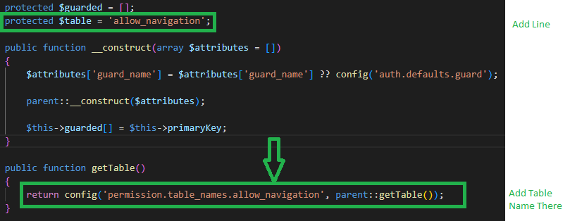

Admin:

Username: admin@gmail.com

Password: 123456